<page_start no = 1>
<sol_start id=1>
1. (3)
<sol_end>

<sol_start id=2>
2. (4)
<sol_end>

<sol_start id=3>
3. (3)
<sol_end>

<sol_start id=4>
4. (3)
<sol_end>

<sol_start id=5>
5. (4)
<sol_end>

<sol_start id=6>
6. The ratio of speed of light in vacume and speed of light in that medium is known as reflective index.
Speed of light in absolut medium = 1.5 × 10⁸ m/s
Speed of light in absolut vacume = 3×10⁸ m/s
Speed of light =
=
<sol_end>
<page_end>

<page_start no = 2>
<sol_start id=7>
7. The fuse used in the series to reduce the chances of burning of any electrical appliance when large amount of electricity pass through the it, it brake the circuit when joule heating takes place fuse melt. If is replaced by the a large rating then fuse don’t melt and circuit continued and due to continued circuit application catch fire.
<sol_end>

<sol_start id=8>
8. Normal vision = u = –25 cm
Corrected vision = v = –75 cm
Defect in hypermetropia
Power = 2.67 D
Focal length = 37.5 cm
<sol_end>

<sol_start id=9>
<sub_id = 1>
9.
given, = 2
A =
P = constant
(i)
or
R_{n} = 4R
<sub_id end>
<sub_id = 2>
(ii) resistivity remains same because it does not depends on length and cross section.
<sub_id end>
<sol_end>

<sol_start id=10>
<sub_id = 1>
10.(i) Puts you into the plane of paper, and Q takes you out of it. The strengt of the magnetic field is larger at the point which is closer to source, which is Q.
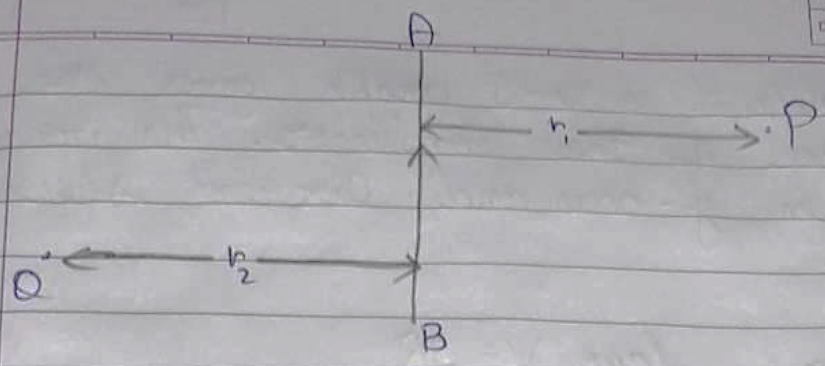
<sub_id end>
<sub_id = 2>
(ii) (a) By using compass, whose niddle shows the direction.
(b) The direction of magnetic field at the center of a current carrying loop in perpendicular to the plane of the loop.
<sub_id end>
<sol_end>
<page_end>

<page_start no = 3>
<sol_start id=11>
<sub_id = 1>
11. (i) In case of
R1 =
V = 3
then,
I = 0.3
In case of R₂
R₂ =
V = 3
Then,
<sub_id end>
<sub_id = 2>
(ii) The slope of a V-I graph gives the resistance of the conductor. The volt shows in y-axis and current shows in x-axis.
<sub_id end>
<sub_id = 3>
(iii) By Ohm’s law V= IR
= slope of V-I graph
Therefor, the slope of the V-I graph represents the effective resistance.
Now in series combination of the resistance all the resistance get seemed up.
Req = R₁ + R₂ + R₃ + ……….+Rn
Therefore, the series combination will have the maximum resistance then the other resistors.
Hence, the line will maximum slope line C will give the series combination of the other two resistors.
<sub_id end>
<sol_end>

<sol_start id=12>
<sub_id = 1>
12. Given are, u = –25 cm
f = – 15 cm
h1 = 4 cm
v = ?
h_{o} = ?
(i) Using mirror formula =
⇒
⇒
⇒
U = –37.5
<sub_id end>
<sub_id = 2>
(ii)
= –6 cm
<sub_id end>
<sub_id = 3>
(iii) 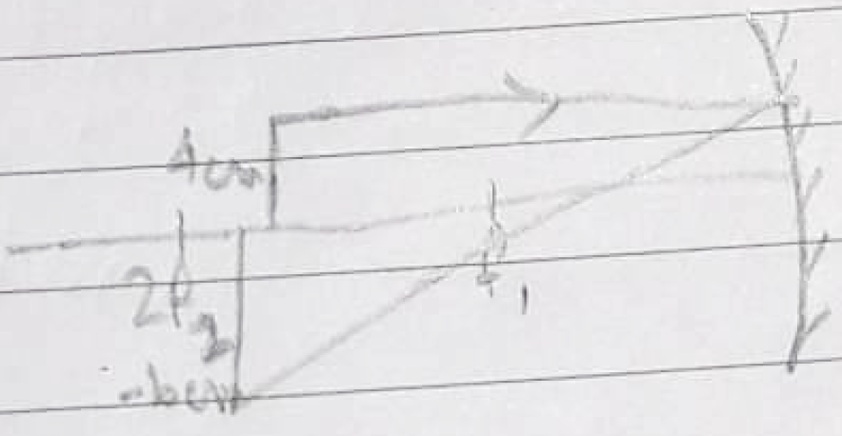 Real, Inverted
<sub_id end>
<sol_end>
<page_end>

